|  |
| --- |
|  |
|  |
| CPM Monitoring  Internal IAM - OAuth Configuration Setup Manual |
|  |
| Version 1.0 |
| February 2025  Copyright © 2025, Oracle and/or its affiliates  Confidential – Oracle Internal |

Table of Contents

1 Document Control 3

2 Glossary 3

3 Introduction of OAuth2.0 Client Credentials Policy 4

4 Configuring OAuth 2.0 in INTERNAL IAM and FUSION Application 4

5 Pre-Requisites 4

6 Navigating an INTERNAL IAM and Fusion APPLICATION 5

7 Important Info To Be Shared By Admin To Caller 29

# Document Control

| Date | Author | Version | Change reference |
| --- | --- | --- | --- |
|  |  | 1.0 |  |

# Glossary

| Abbreviation | Definitions |
| --- | --- |
| IAM | Identity and Access Management |
| OIC | Oracle Cloud Infrastructure |
| OIC | Oracle Integration Cloud |
| PaaS | Platform as a Service |
| REST | Representational State Transfer |
| API | Application Programming Interface |
| WS | Web Service |

# Introduction of OAuth2.0 Client Credentials Policy

It's recommended to use OAuth 2.0 to avoid issues like password management, expirations, and policy changes. This single setup streamlines user roles and aligns with Oracle's new security standards.

In essence, using OCI Cloud Console and IDCS/IAM Access aligns strategically with Oracle's advancements. This, coupled with OAuth 2.0's effectiveness, promotes modern security practices and smooth transitions between releases, ensuring continuous and efficient monitoring functions.

# Configuring OAuth 2.0 in INTERNAL IAM and FUSION Application

This configuration is applicable for Customers who have Internal IAM where Fusion Applications are available in the same tenancy. This method enabled customer to maintain one IAM Instance for Integrations and RestAPI Configuration Clients and Resources along with Fusion Application. Clients commence by registering through a confidential app creation in Oracle IDCS/IAM. This app becomes the gateway for clients to seek access tokens from Oracle IDCS/IAM. Subsequently, the access token from this app is acquired, granting them access to safeguarded resources within various requesting applications.

# Pre-Requisites

These steps are performed who primarily have admin access to navigate to Oracle IDCS/IAM Administrator and admin access to navigate to SaaS Fusion Application.

Open a Notepad and save as Oracle_IAM_Artifacts.txt in the Document Folder with the content “Artifacts to be Shared By Admin to Caller”

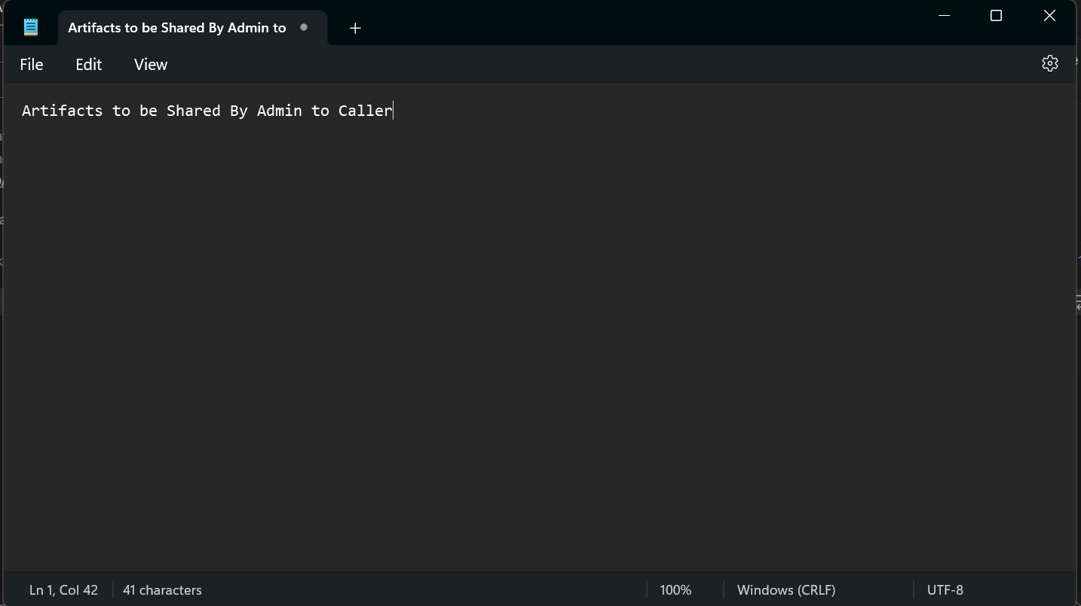

# Navigating an INTERNAL IAM and Fusion APPLICATION

1. Navigate to **https://cloud.oracle.com** and inputting your tenancy name. Then, log in to the OCI platform after providing the credentials.
2. To access the Oracle Identity console, proceed to **"Identity & Security"** and click on **"Domains."**

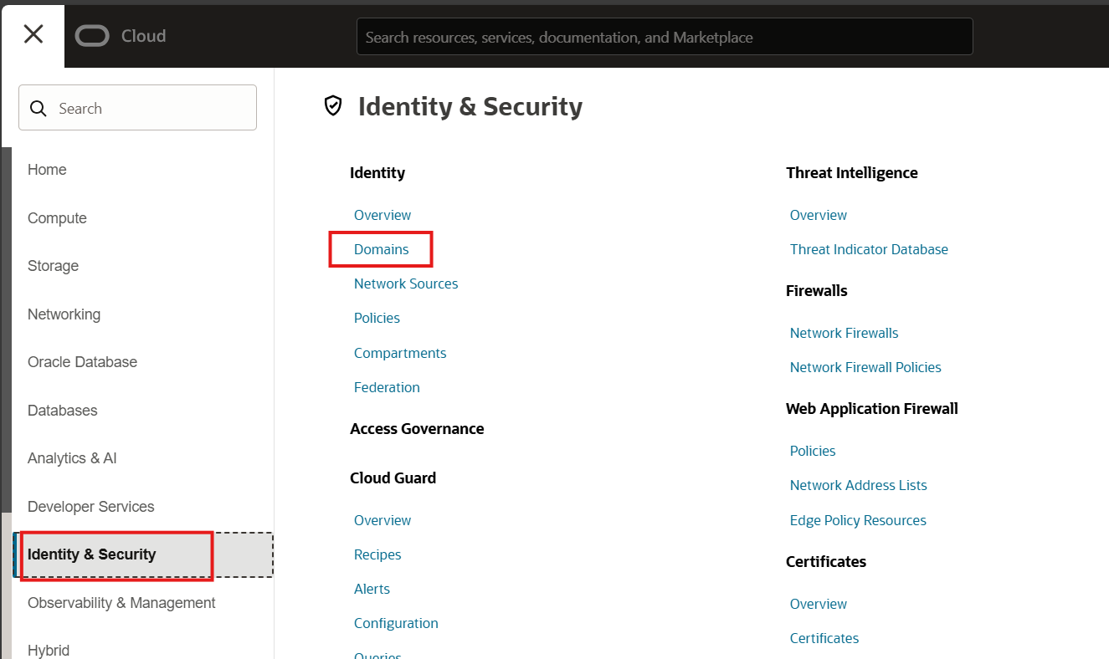

1. Open the Fusion Environment (in which OAuth needs to be configured) related domain if it exists in OCI Console. If not, then you can navigate to Current Domain from the Domain Screen.

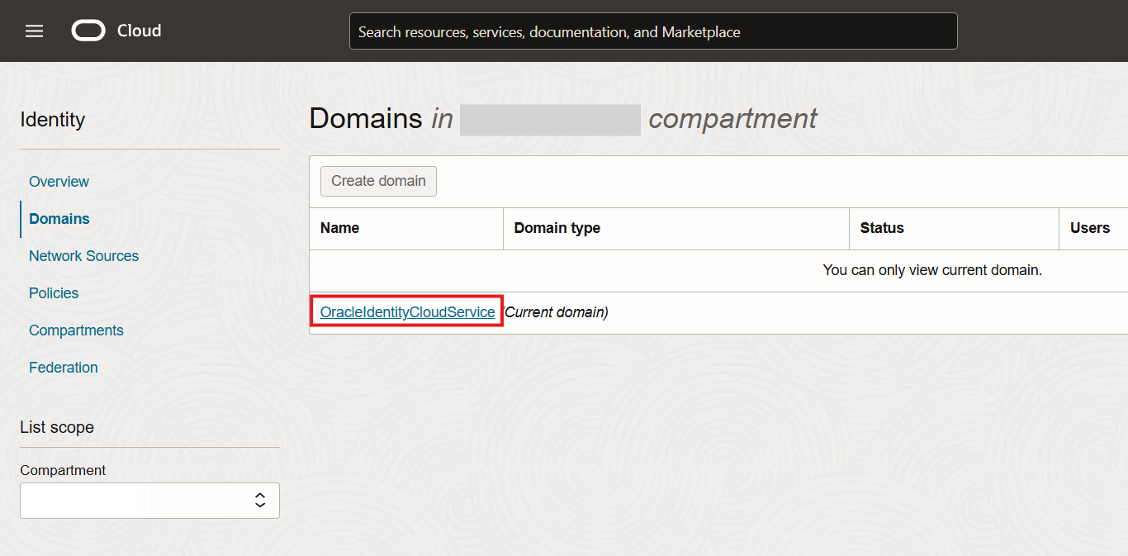

1. Open Oracle Identity Cloud Service Console and copy the Domain URL.

NOTE: Before noting the Domain URL, validate if the Domain URL matched with the IDCS value present in Fusion Application.

**Verification of Domain URL**

* Navigation: In Fusion Home Page, Click on Navigator/Hamburger Menu, select Tools and click on Security Console.
* Select API Authentication and select the <https://identity.oraclecloud.com> and against this application the IDCS is populated. Cross Verify if it is the same as Domain URL.
* If yes, proceed with next steps as mentioned in the document. If not cross check with the relevant domain and configure in that domain.

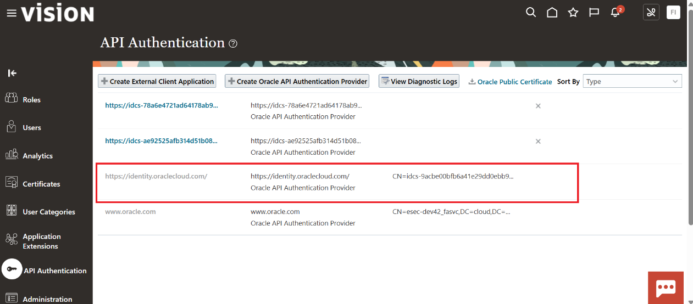

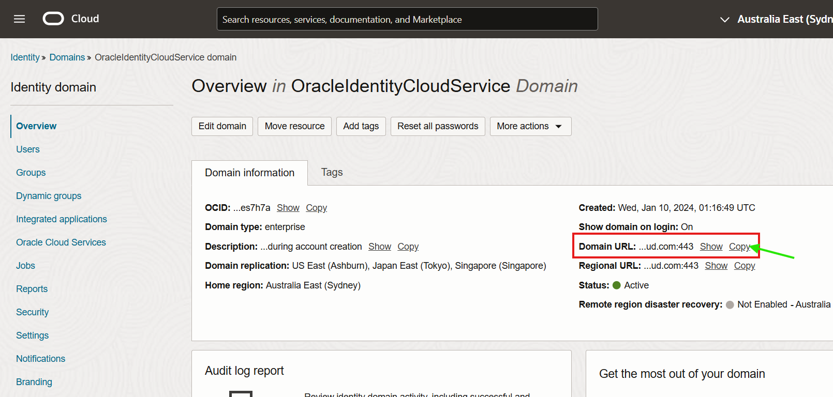

1. Paste the Domain URL in the Notepad with the name “Domain URL”.

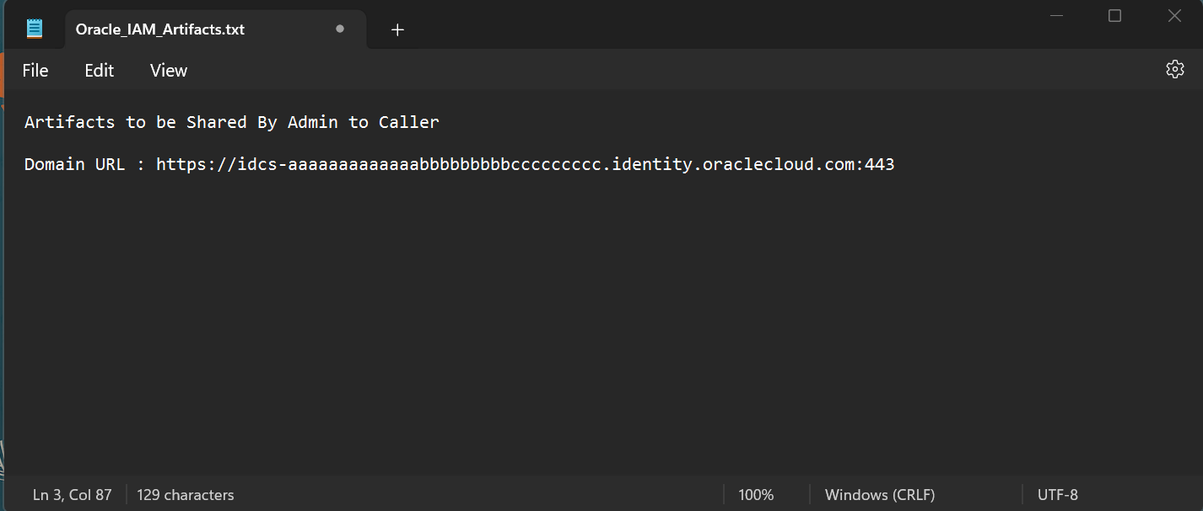

1. Login into same Cloud Console and Navigate to Identity and Security

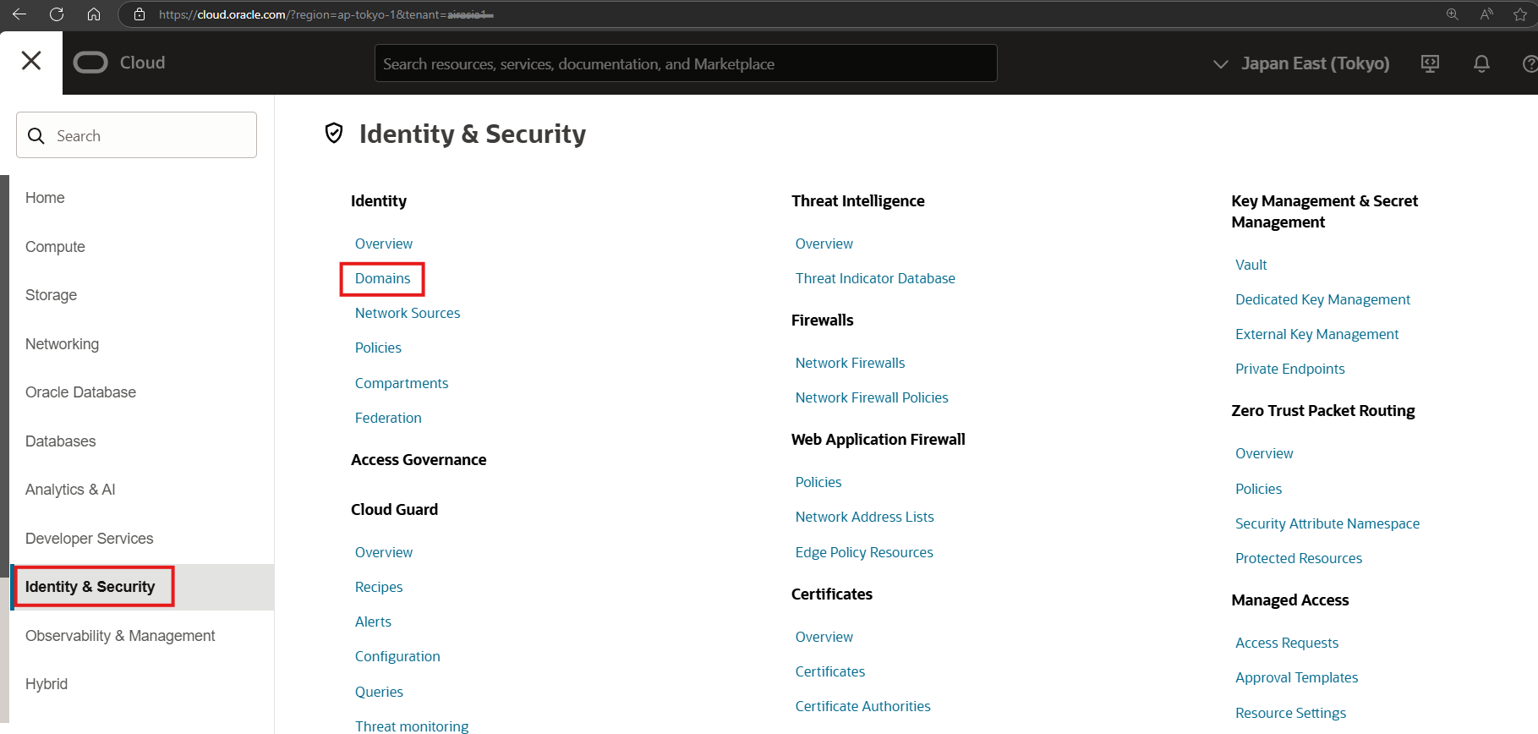

1. Navigate to the Domain

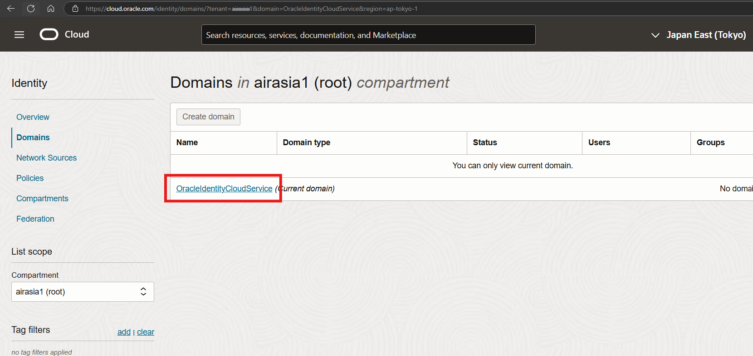

1. Select Integrated Applications and click Add Application

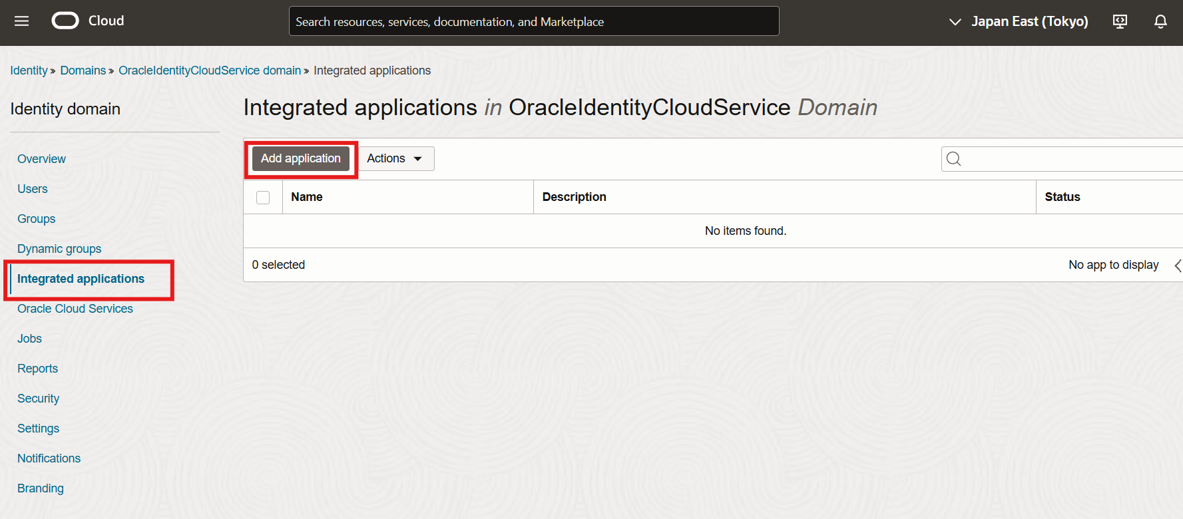

1. Select Confidential Application and Click Launch Workflow

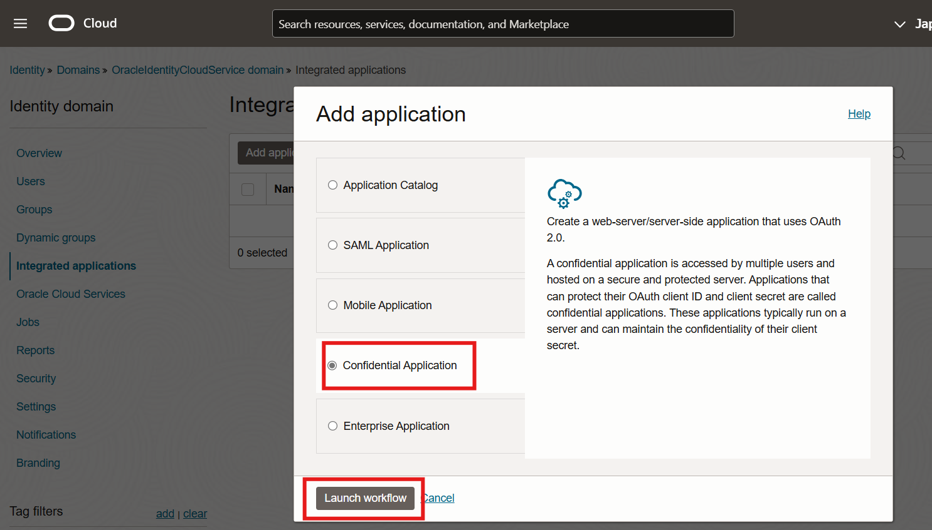

1. Name the application as “OAuth_CPM_FA_RestAPIs_Application” and description as “OAuth Confidential Application for FA RestAPIs”, Leave the rest of the Fields as is and then click Next.

NOTE: The naming convention can be mentioned as per customer requirement.

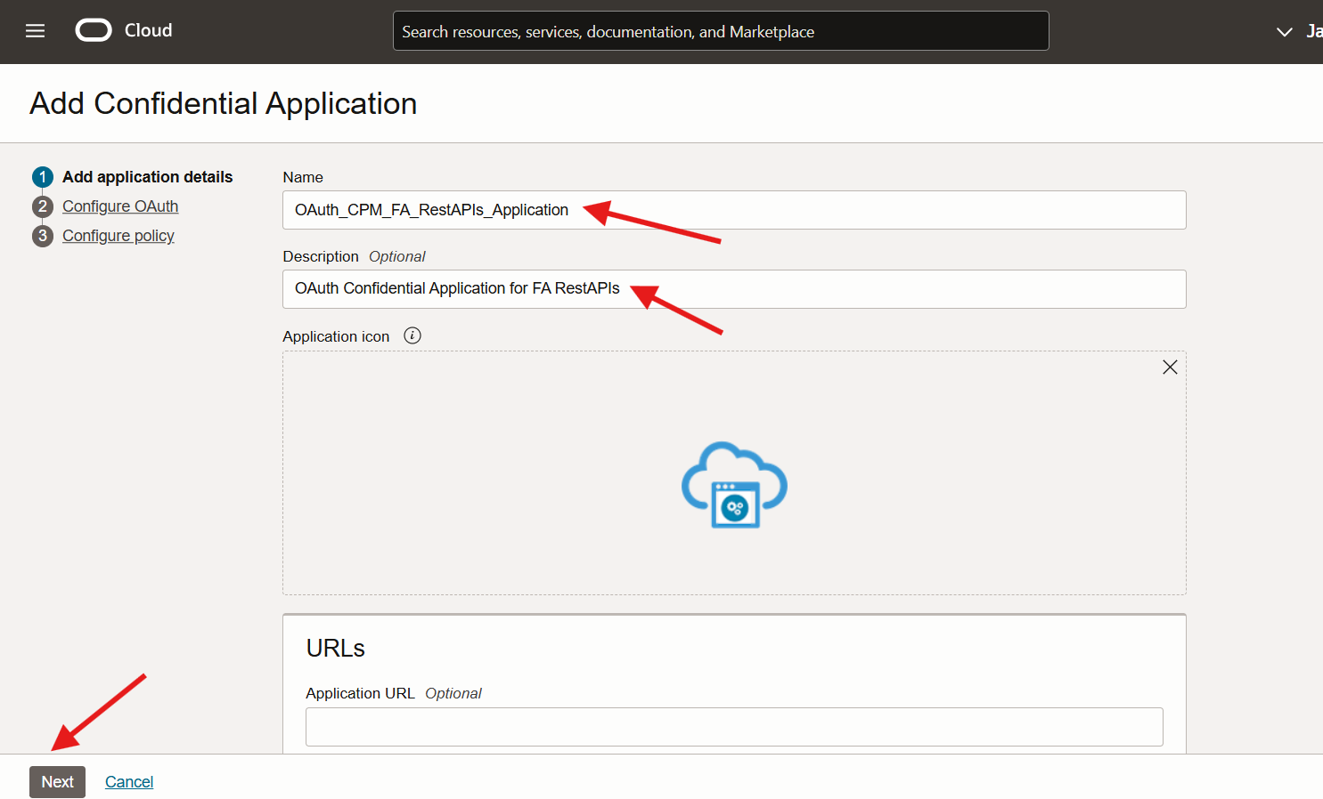

1. Select the Option “Resource Server Configuration”

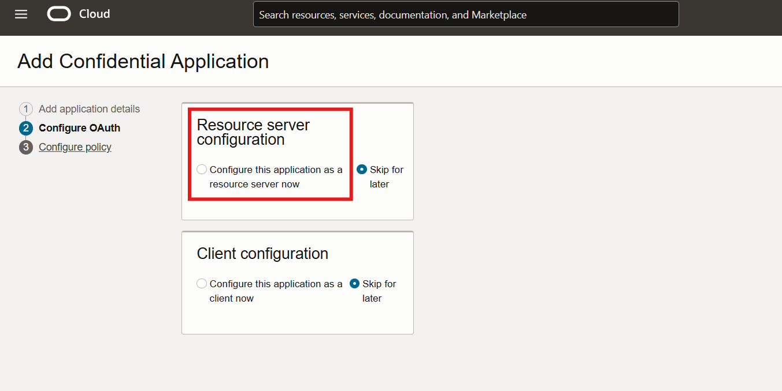

1. Open the Artifacts Notepad and Copy the FA URL

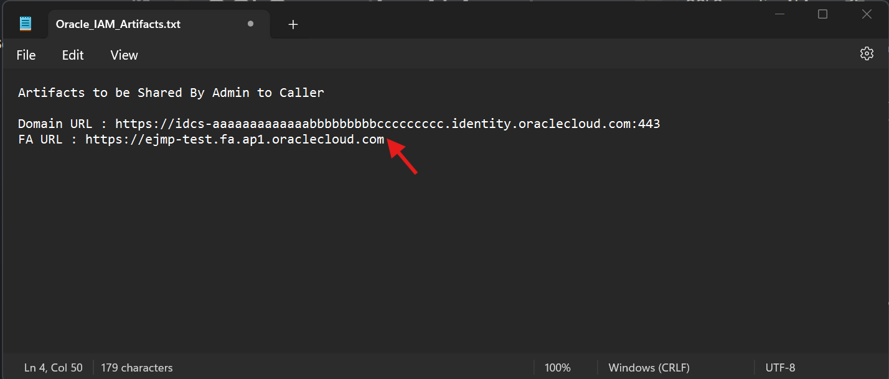

1. Keep the Access token expiration (seconds) to 3600, click Allow token refresh , Keep Refresh token expiration (seconds) 604800 and update Primary audience with the Fusion Application URL.

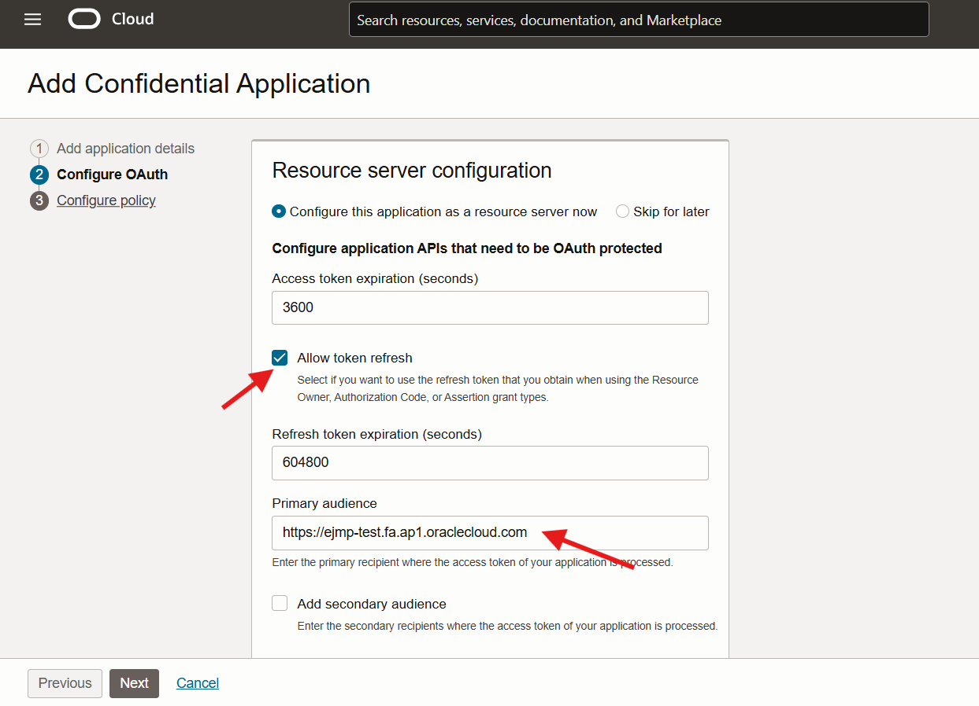

1. Scroll Down and Select “Add Scopes” then click Add Button to add the below scope
   * Scope : /
   * Description : All
   * Tick Requires User Consent

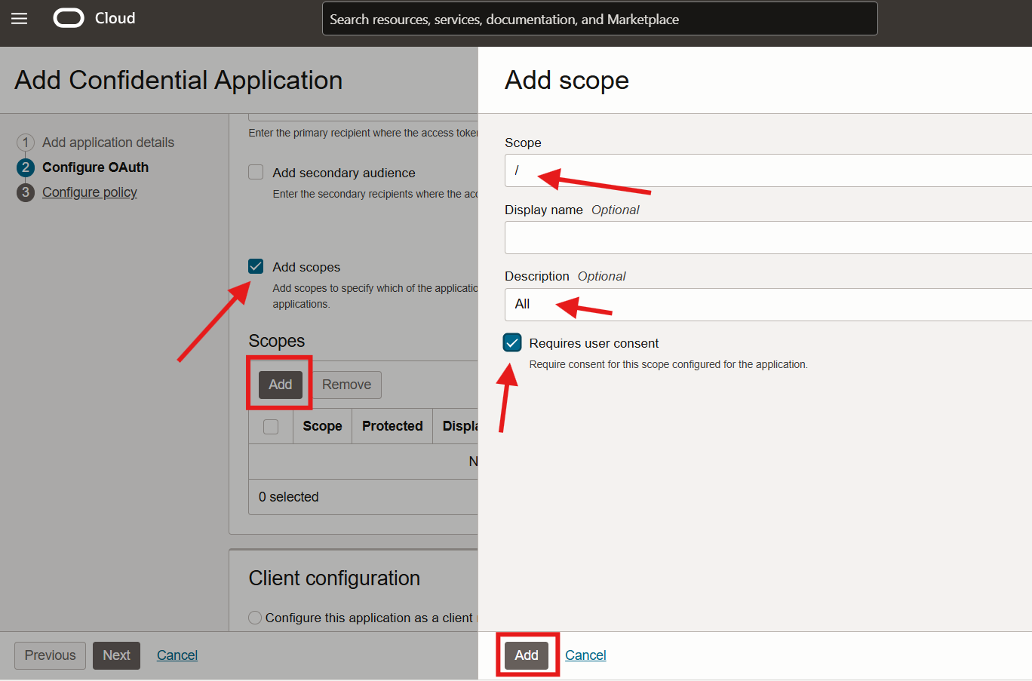

1. Validate the added Scope and click Next

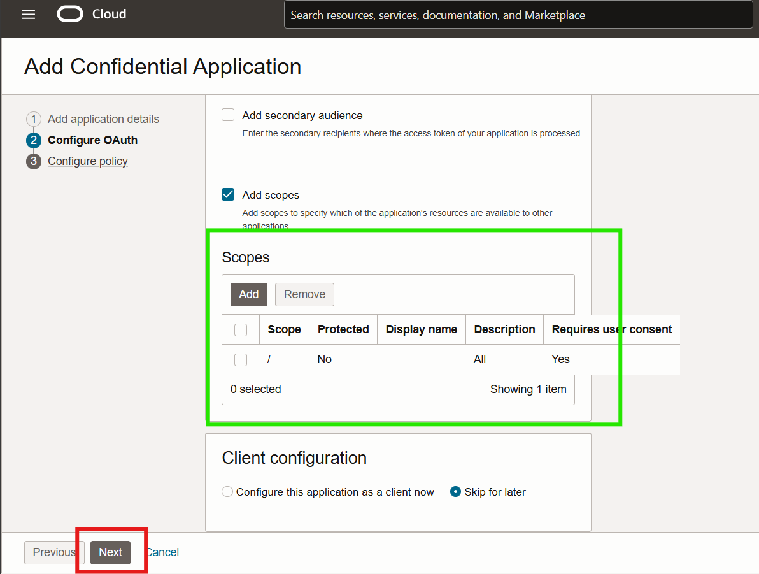

1. No changes required in the next screen , press Finish Button

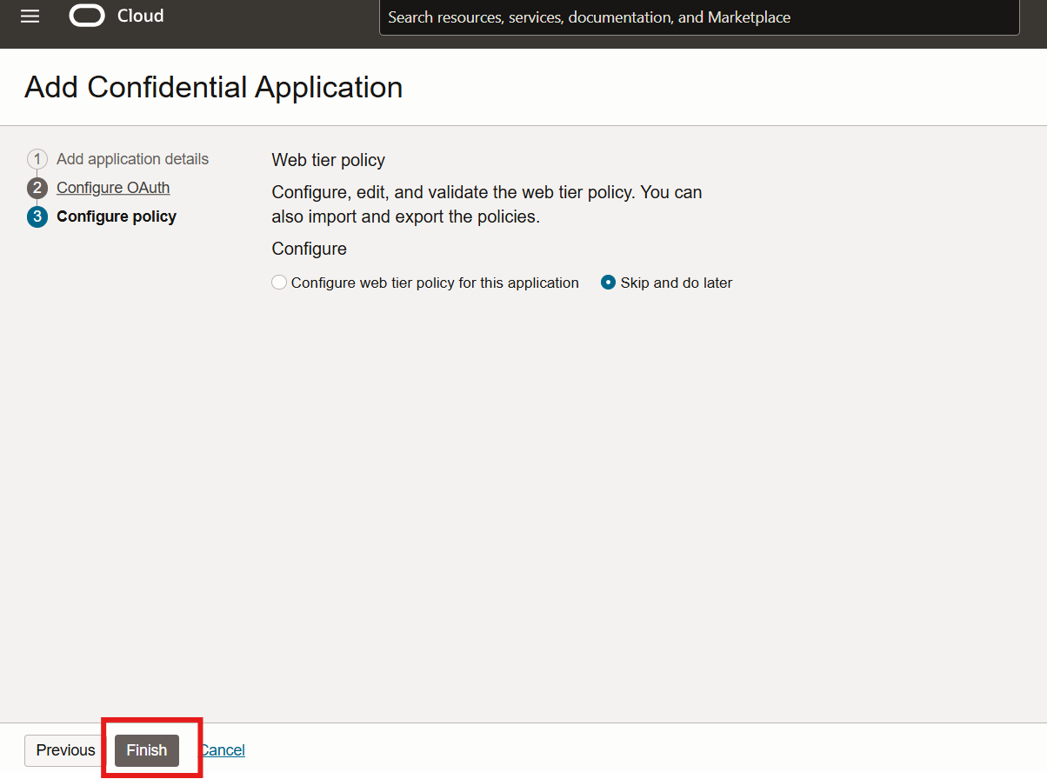

1. Click the Activate Button

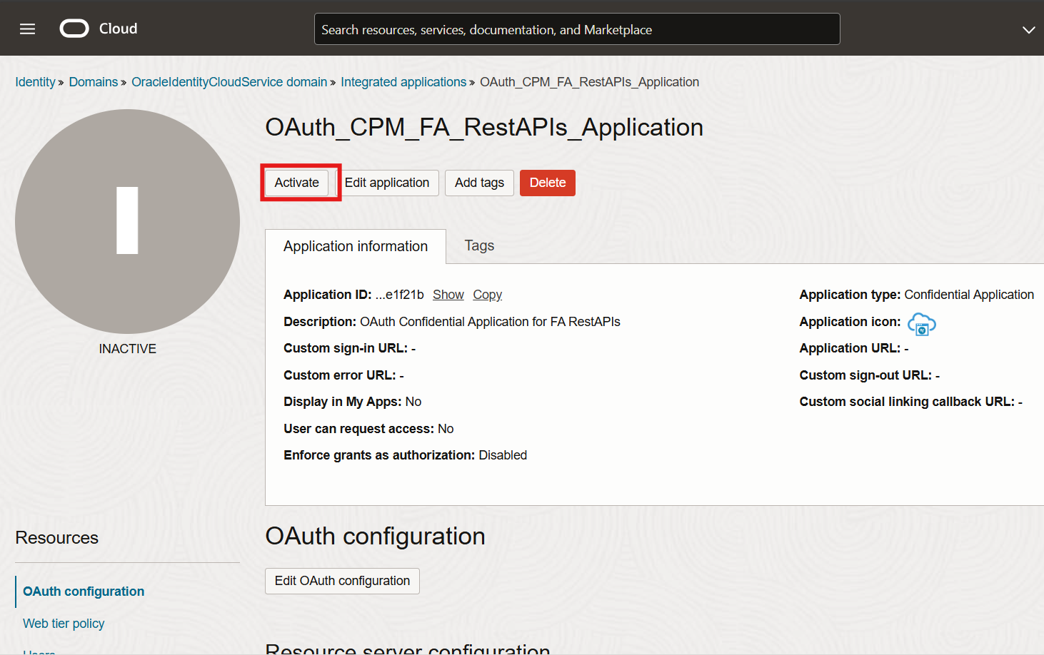

1. Activate the Application

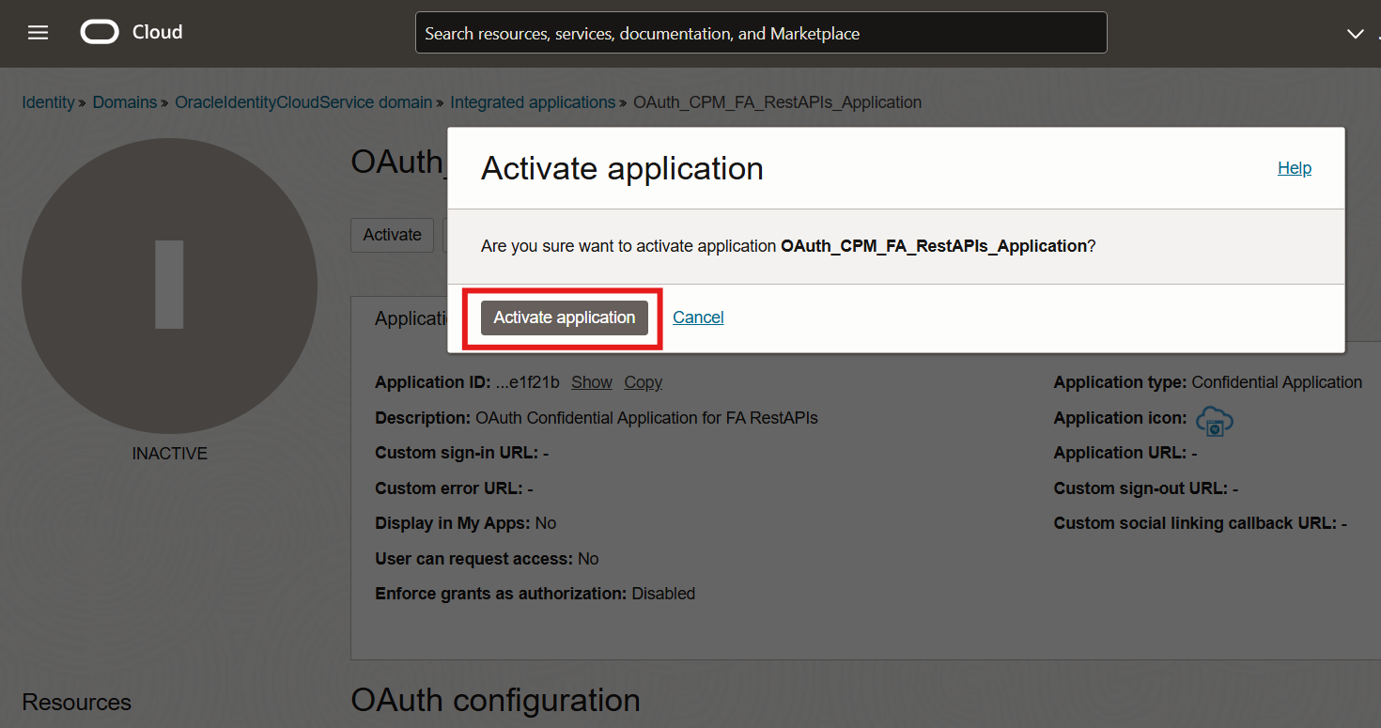

1. Make sure application is Active

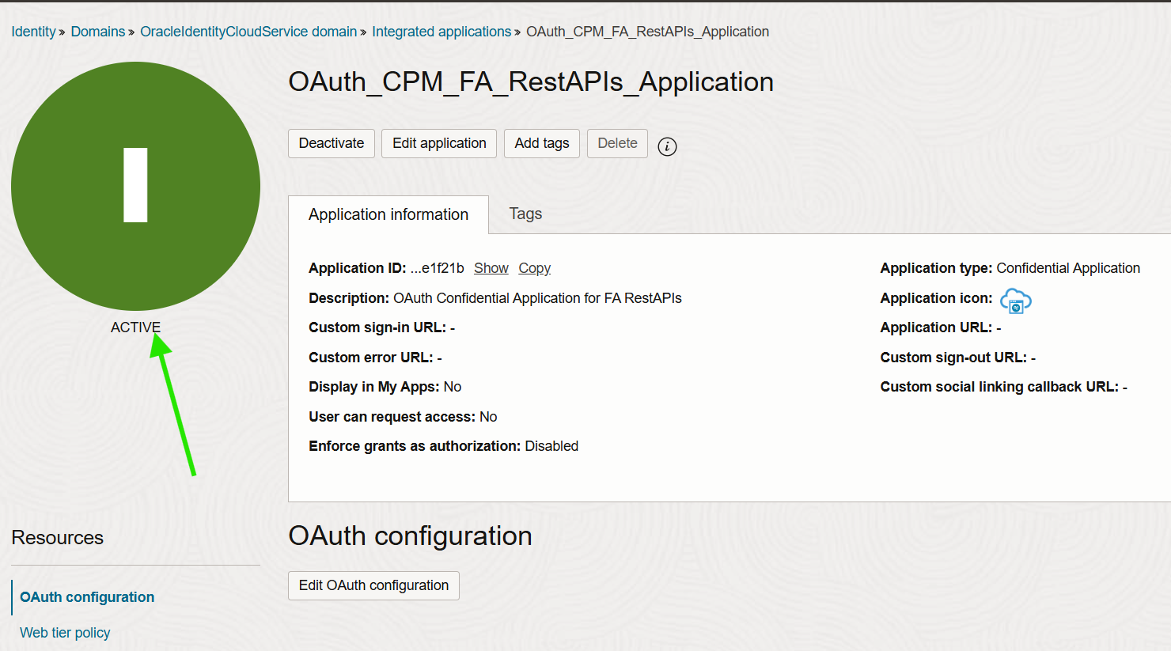

1. In the same screen Select Edit OAuth configuration

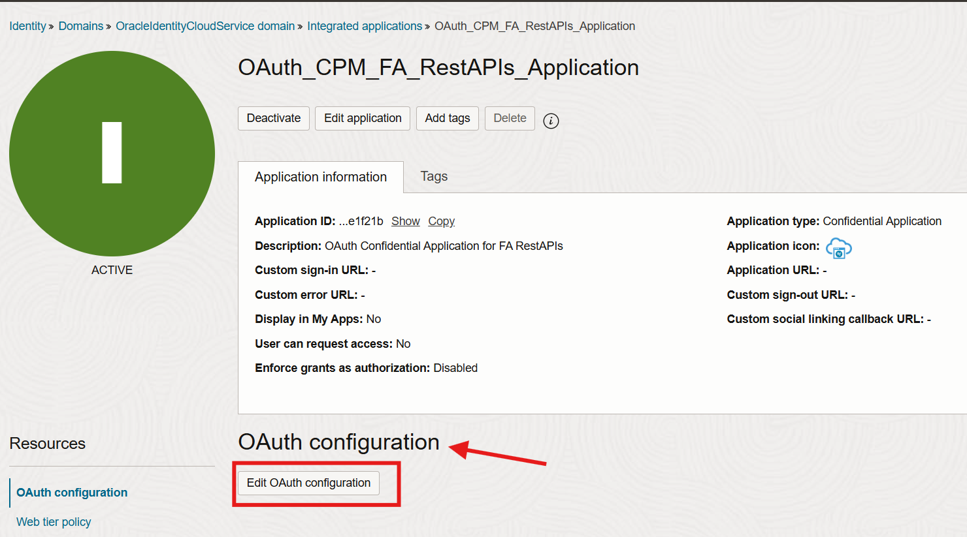

1. In the Popup , Scroll Down and Select Client Configuration

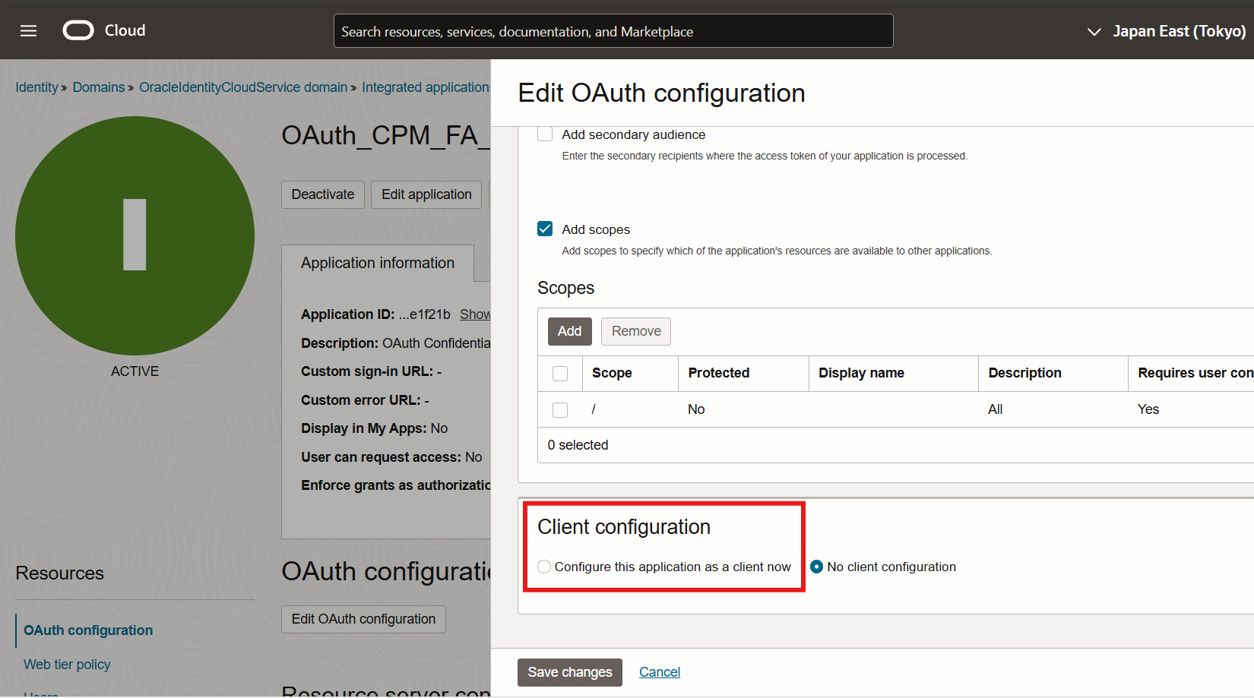

1. In the Authorization Section , select Client Credentials

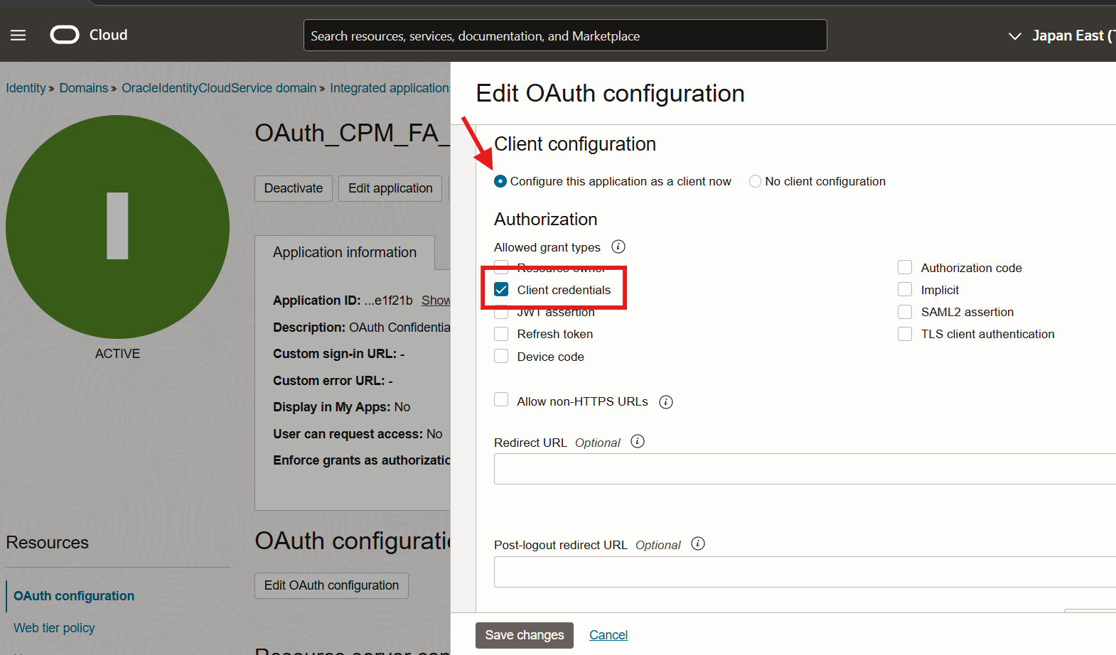

1. Scroll Down and go to section “Token Issuance Policy” and select Specific Option

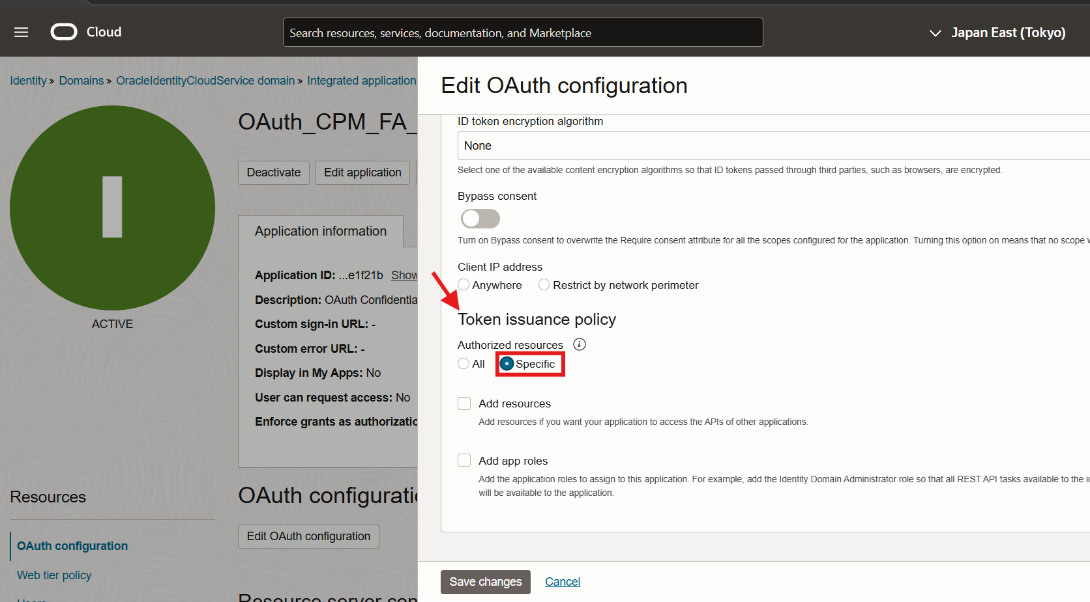

1. Select Add Resources and Click the Add Scope Button

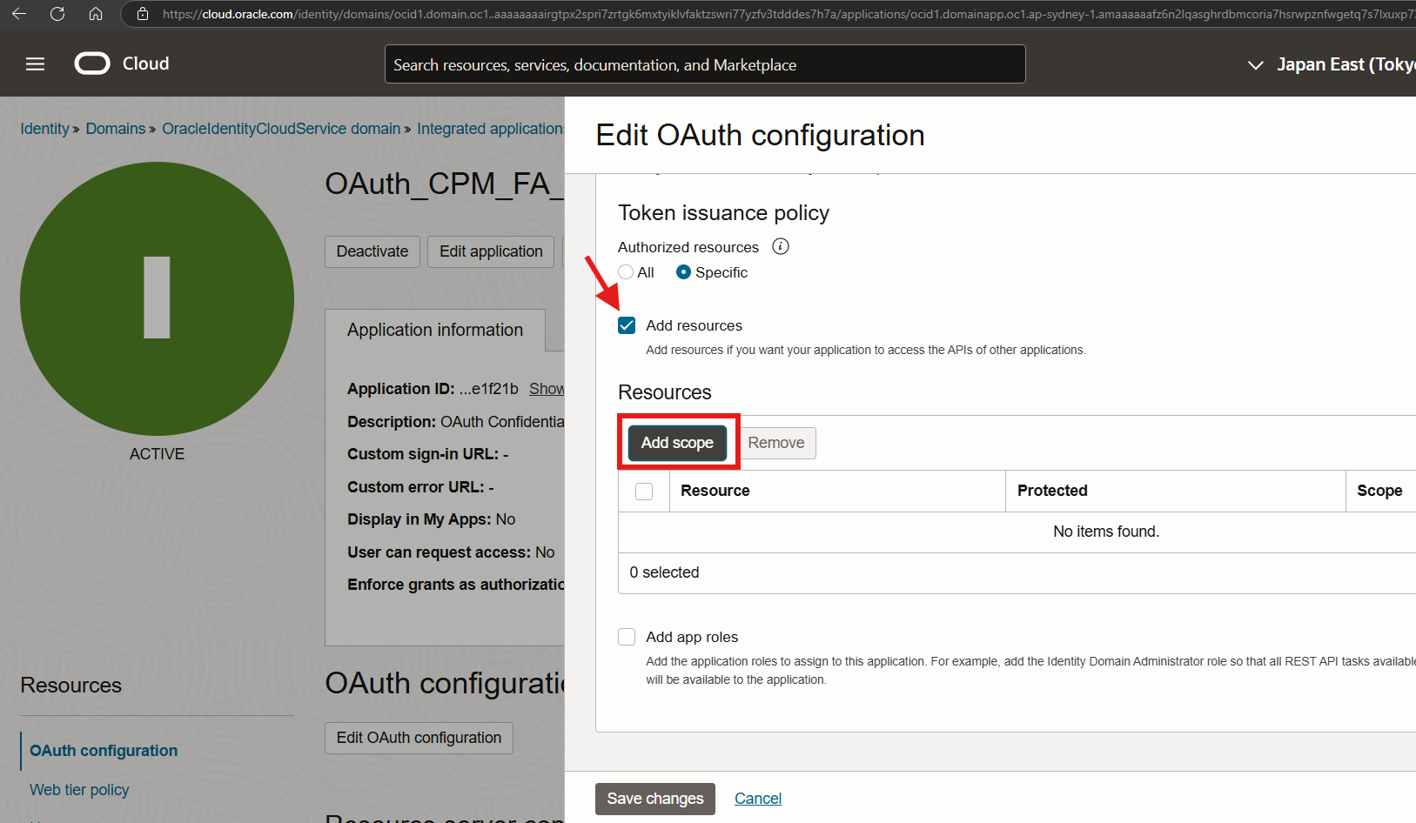

1. In the Popup window , search and select “OAuth_CPM_FA_RestAPIs_Application , then click Add.

NOTE : If the Name of OAuth has been changed while configuring in Step 10, select the scope accordingly.

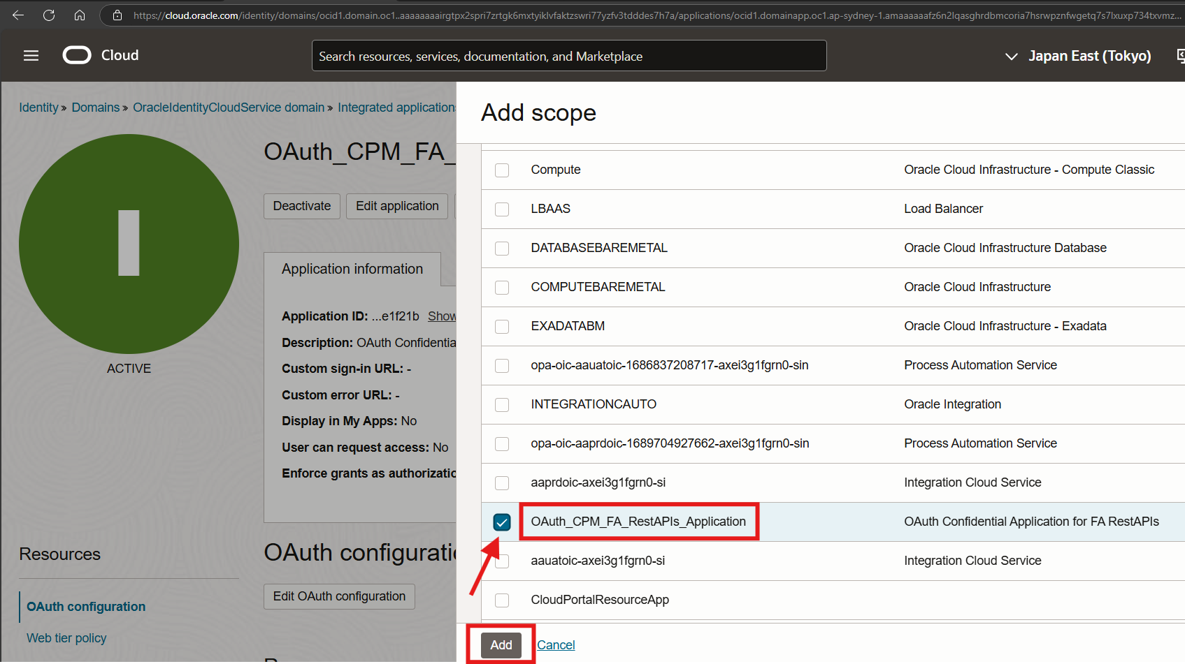

1. Make Sure scope this entry selected from the Popup and click Save Changes

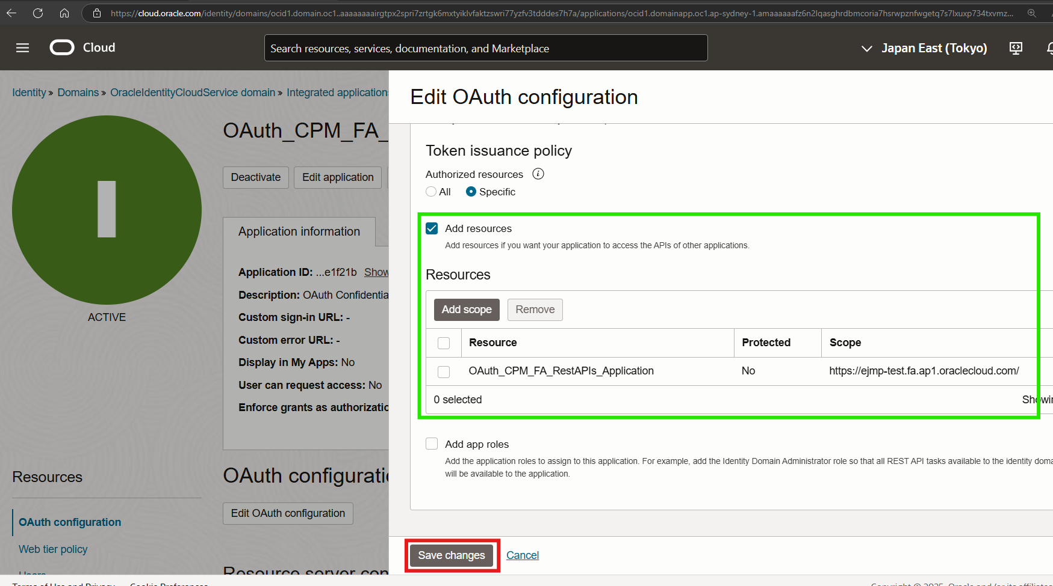

1. Validate and make sure application is Active

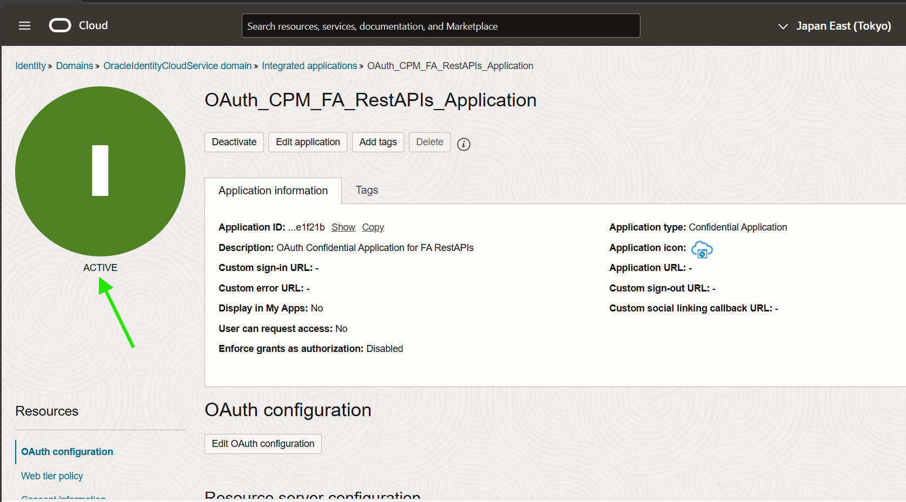

1. In the same page scroll down to the General Information section and copy Client ID to the Oracle_IAM_Artifacts.txt

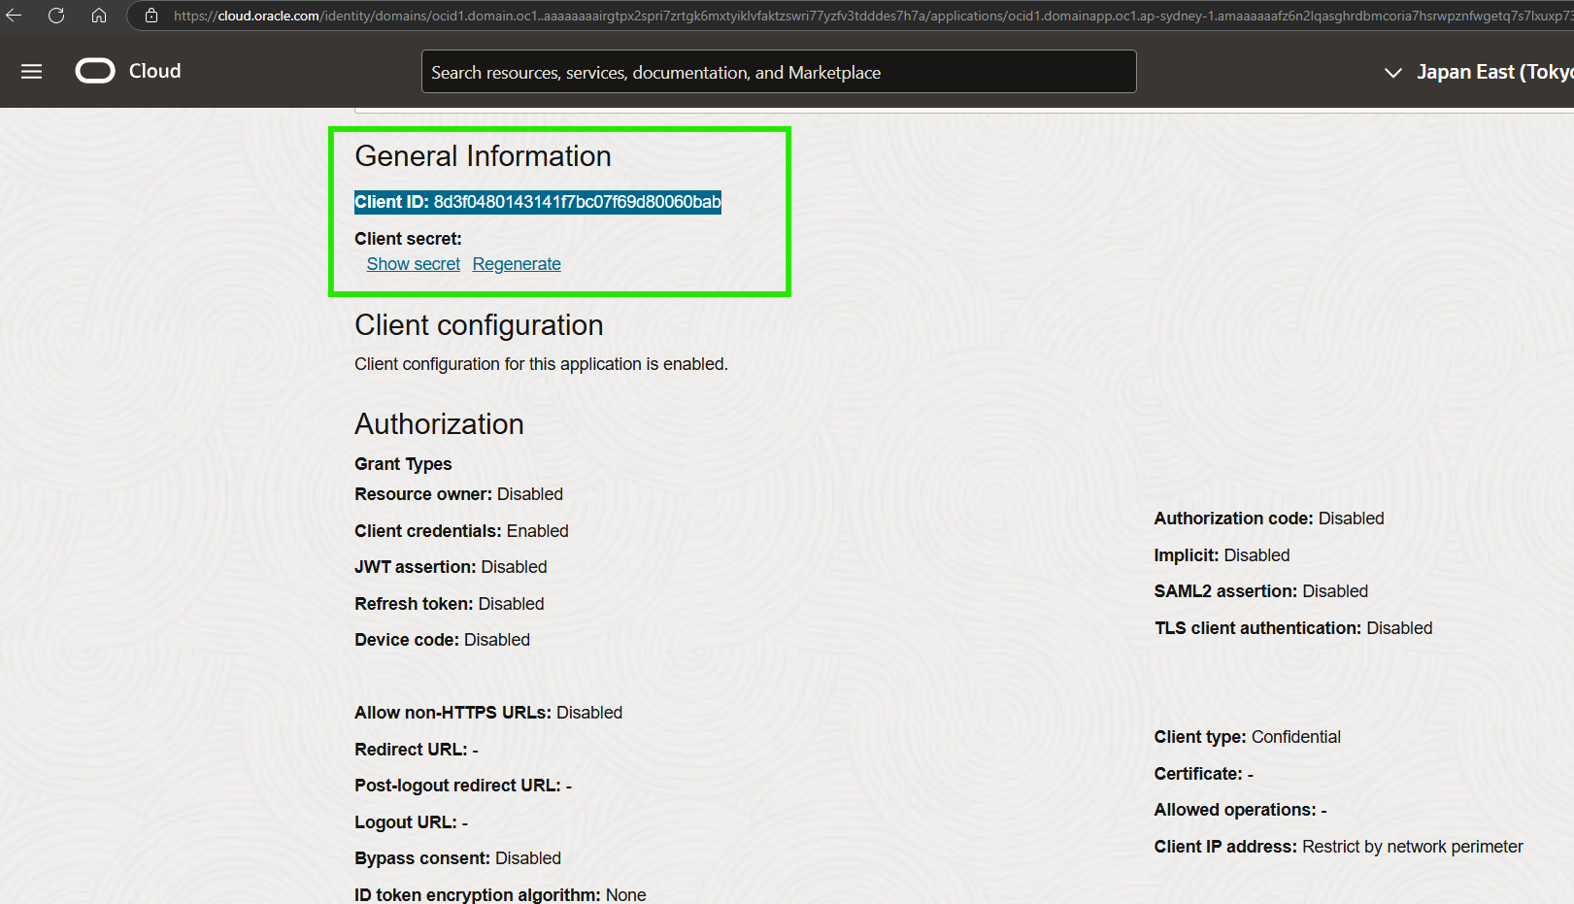

1. Paste it in the Oracle_IAM_Artifacts.txt file

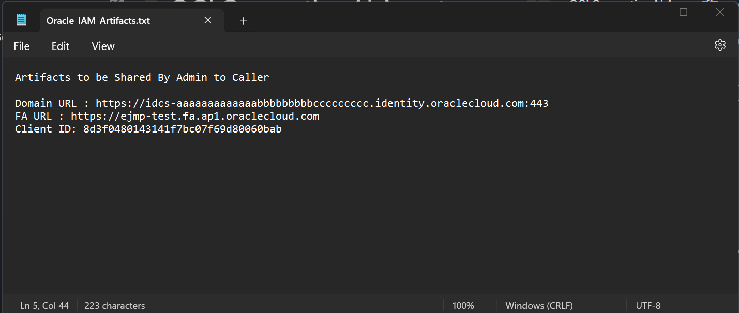

1. In the same page click the Show Secret link

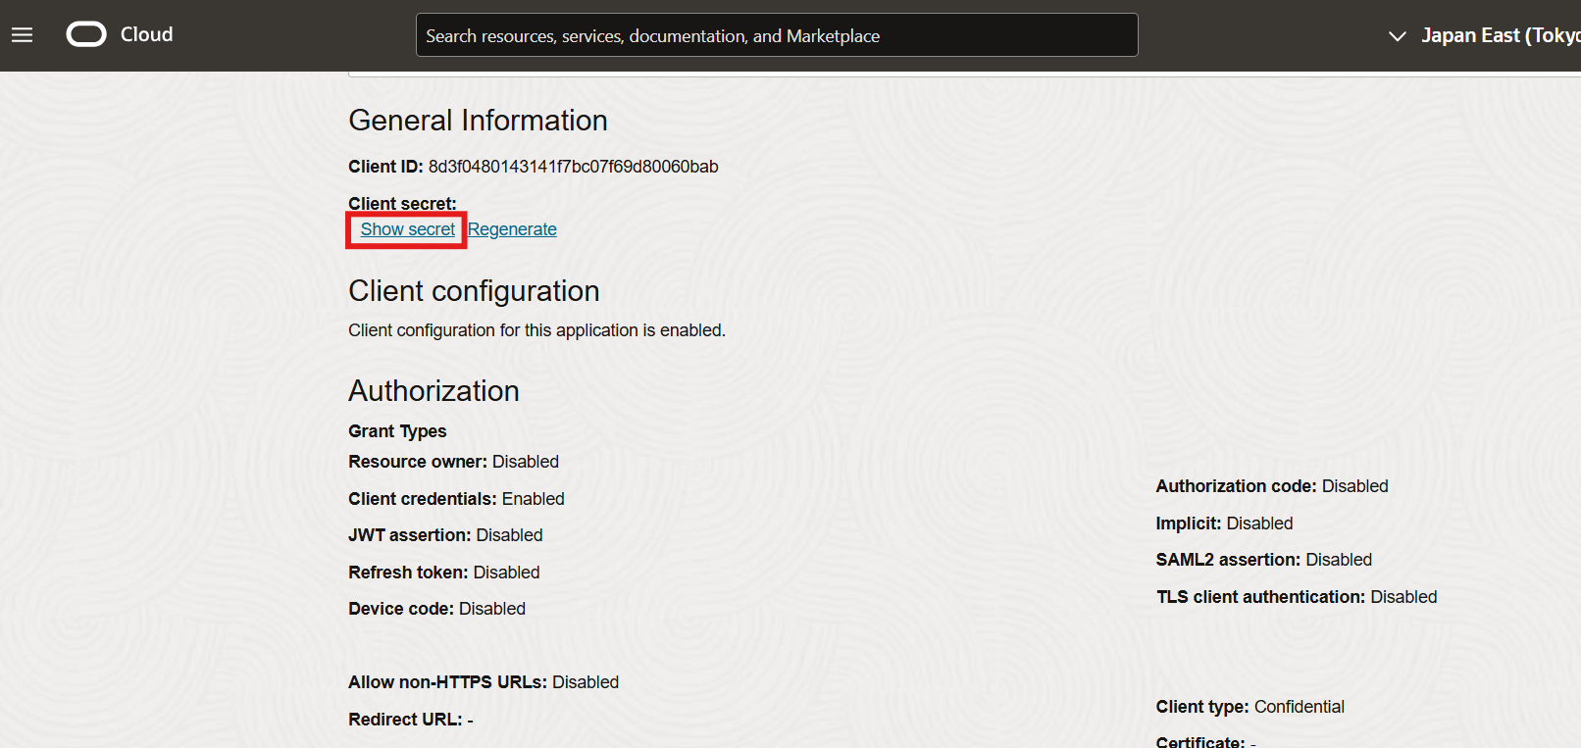

1. Click Copy and Close the Dialog

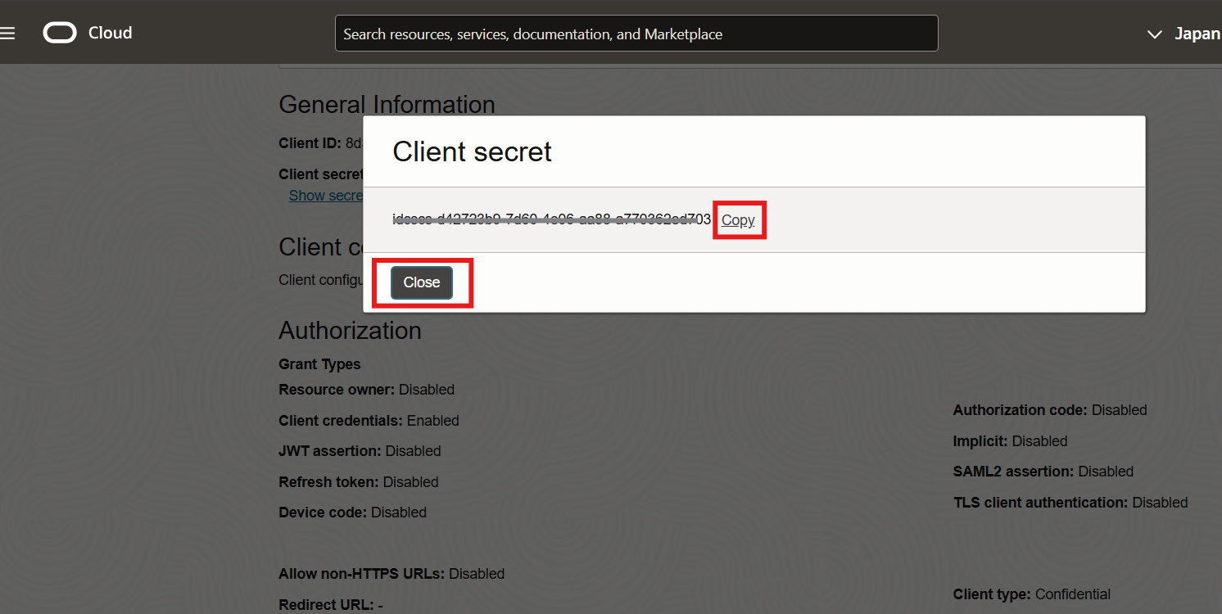

1. Open the Oracle_IAM_Artifacts.txt Notepad and add an entry Client Secret and paste the content.

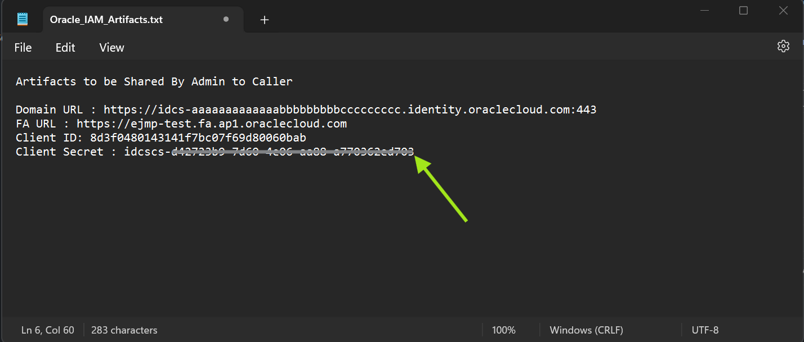

1. Login into your Fusion Application Instance

Open a Browser and Loging with the URL , use a validate admin username

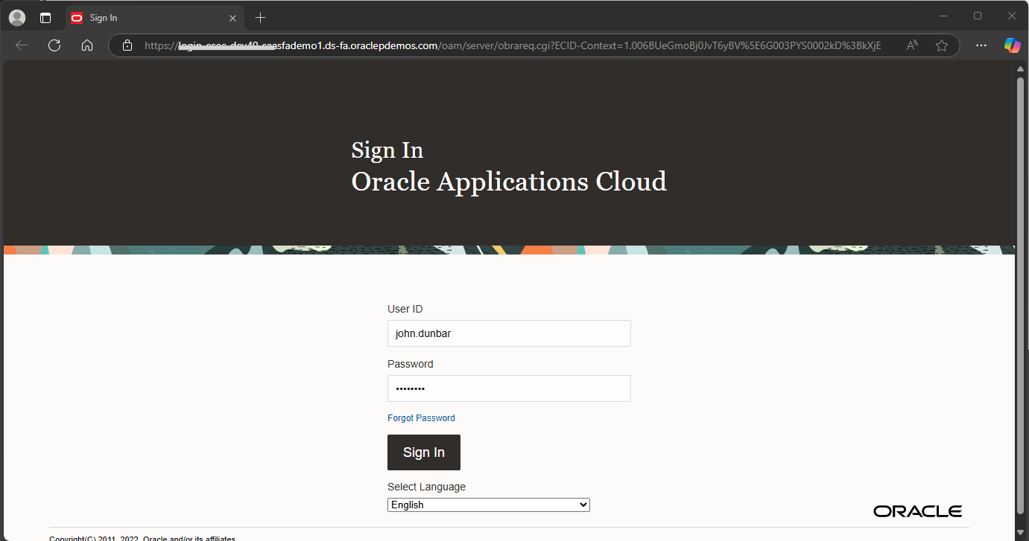

1. Click the Hamburger Menu

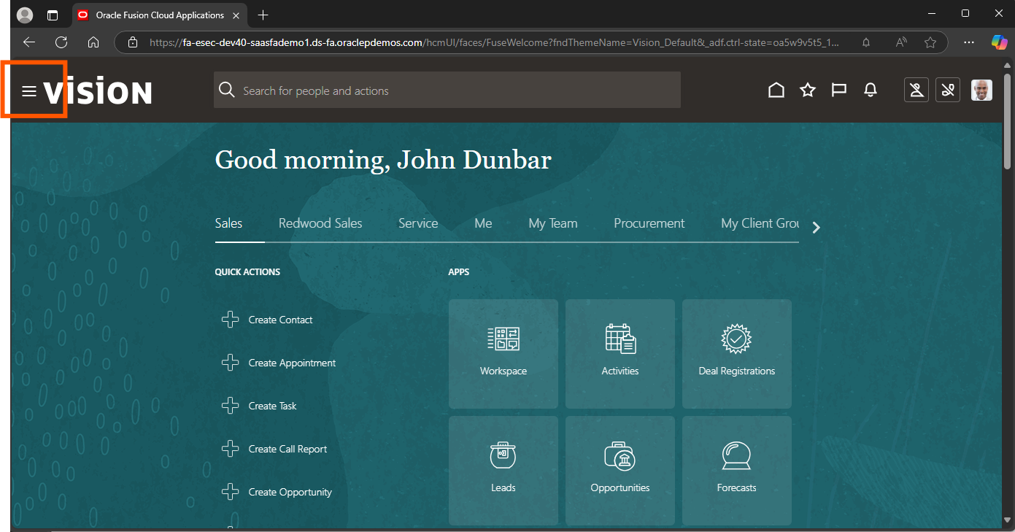

1. Select Security Menu

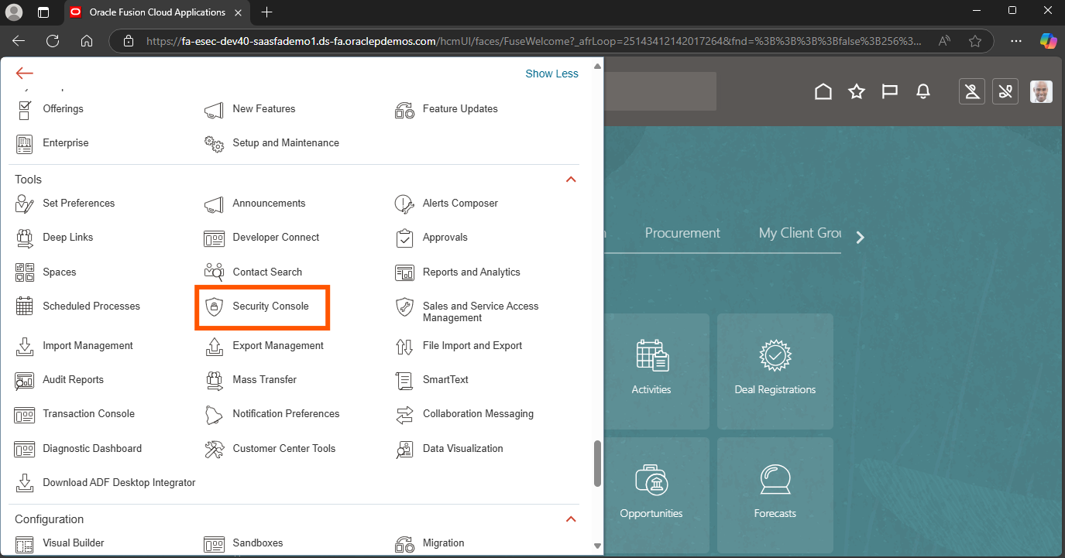

1. In the Security Console select Users and Add User Account

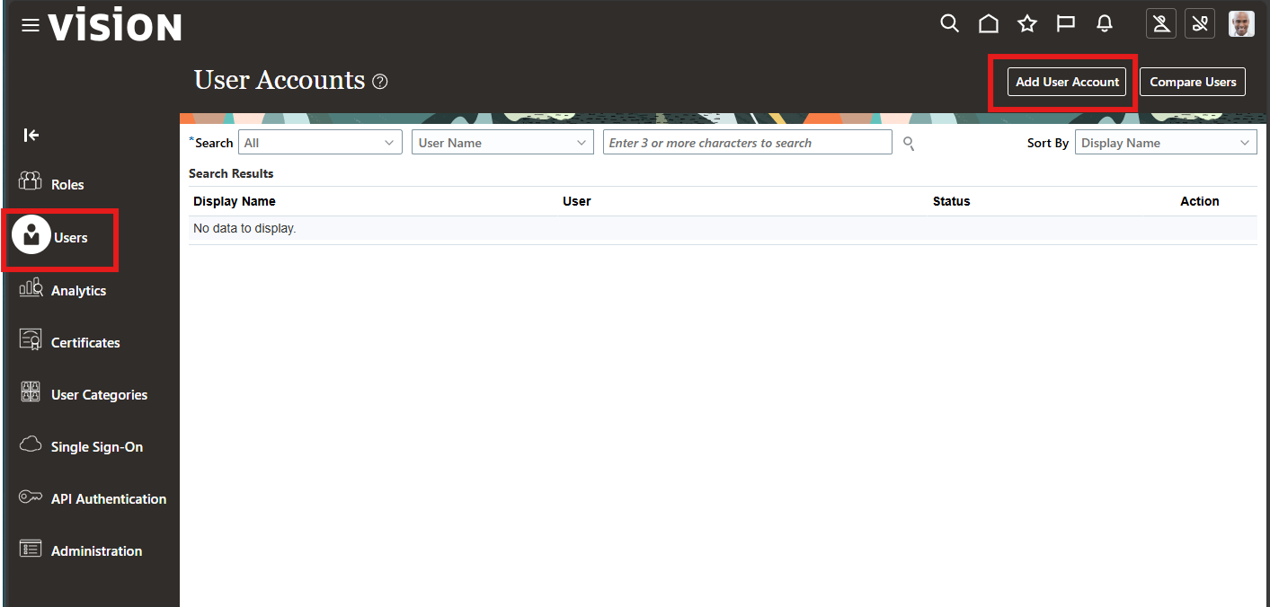

1. Copy the Client ID from the Artifact Notepad Oracle_IAM_Artifacts.txt

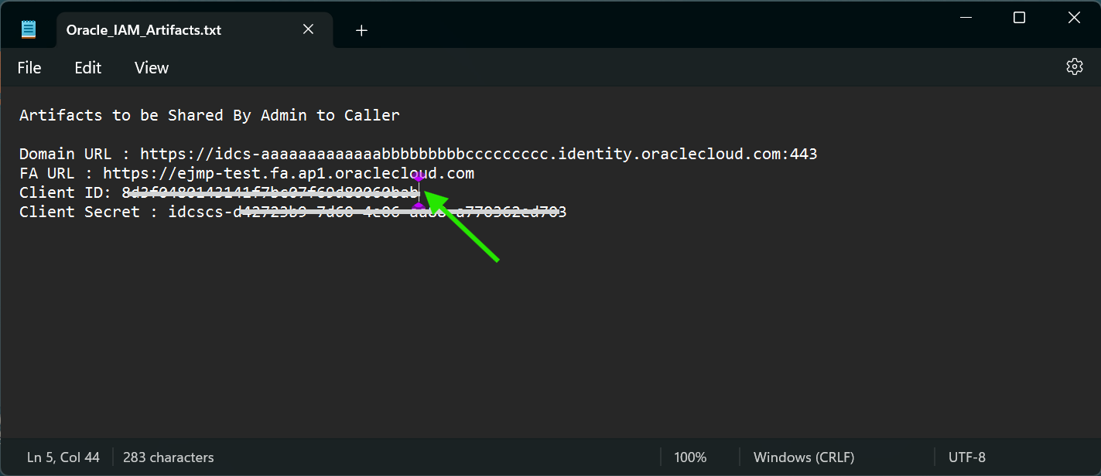

1. For the password use the last chunk from the Client Secret

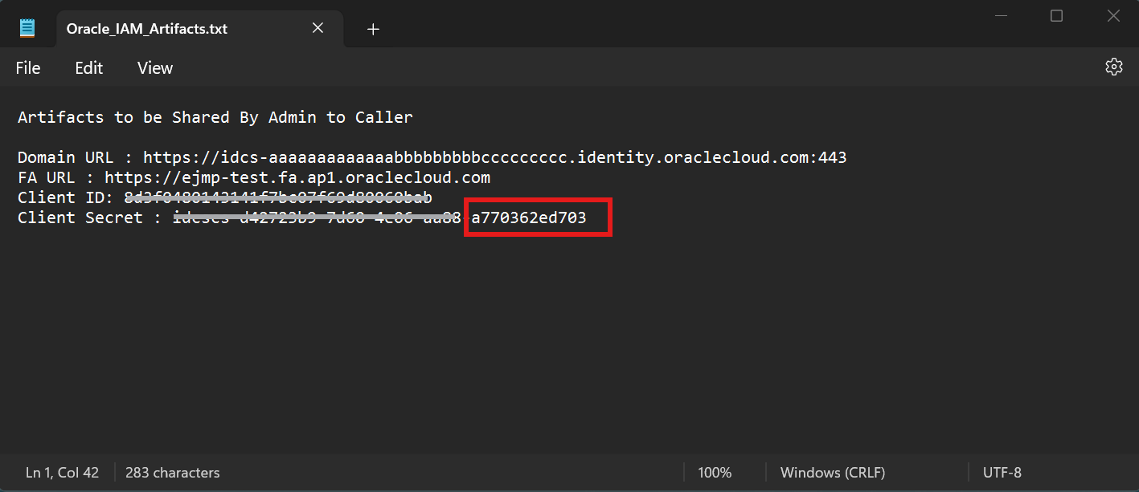

1. Create the User in Fusion Application. Last Name give CPM_MONITOR , File in the User Name from the Artifact Notepad and for the Password copy the last chunk from the Artifact Notepad attribute Client Secret.

NOTE: The Username must be Client ID. The Password can be changed as per customer security guidelines. Please verify before creation of user account.

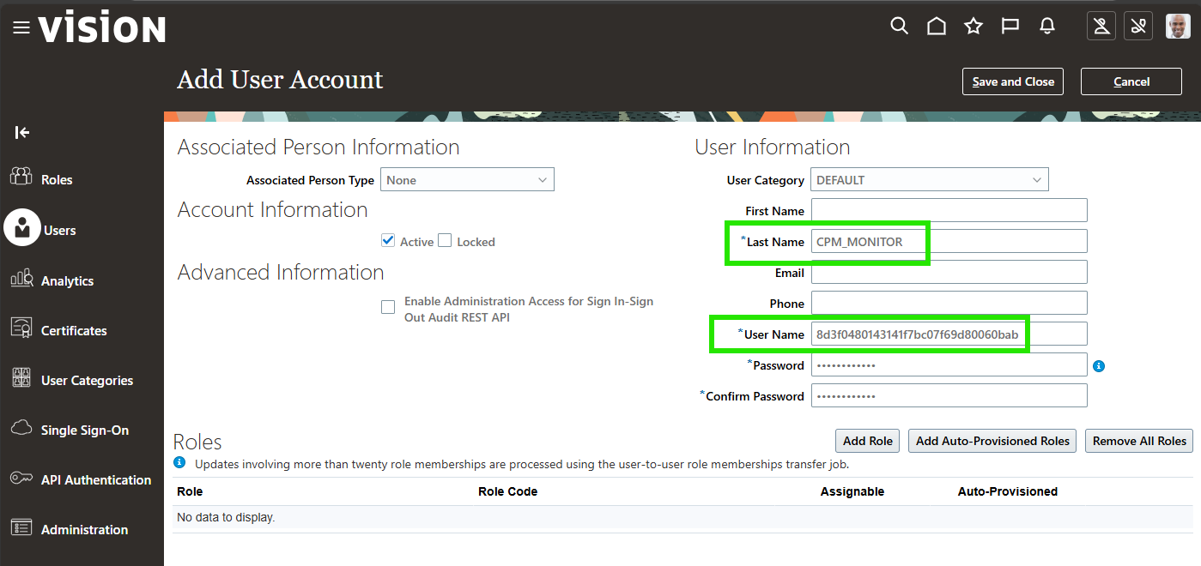

1. Click Add Role

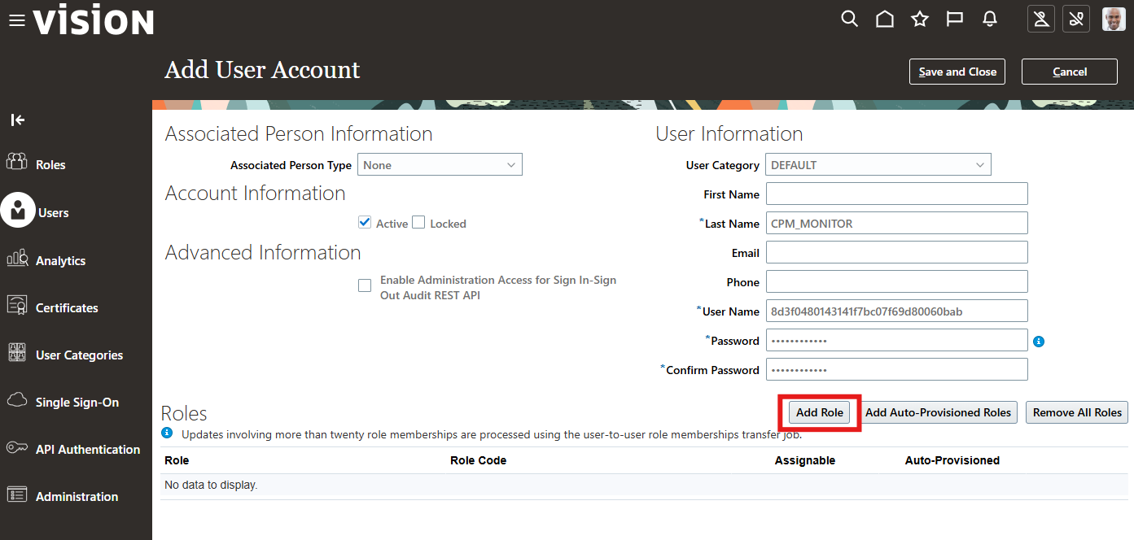

1. Select appropriate Role available in your environment to grant access to the required features.

In this case ESS Monitor role is assigned to fetch ESS runtime details.

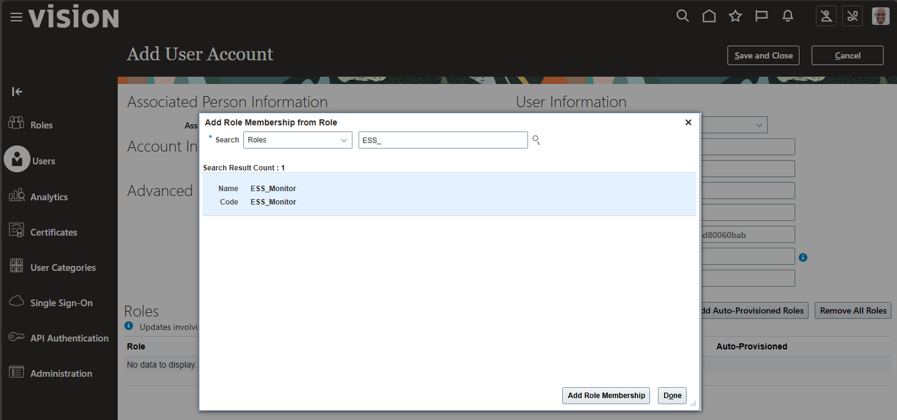

1. If the ESS Monitor role is not available (Follow Step 42 – 49). Navigate to the Roles under Security Console and click on Create Role.

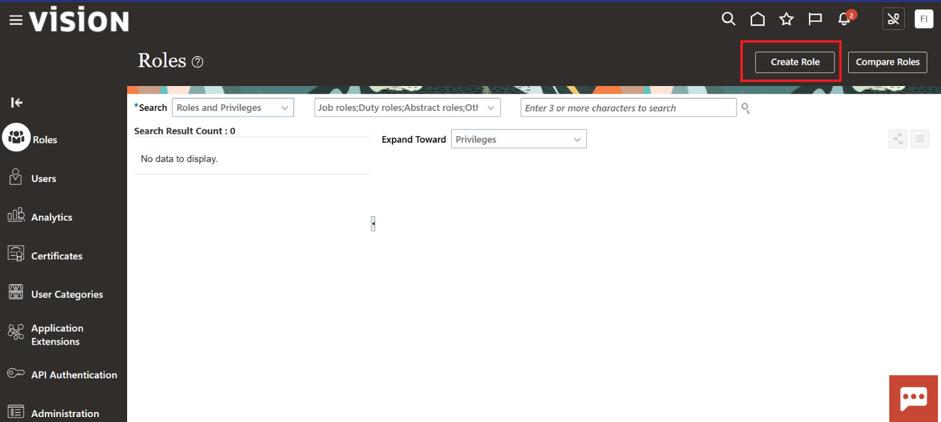

1. Enter the Role Name, Role Code and Role Category.

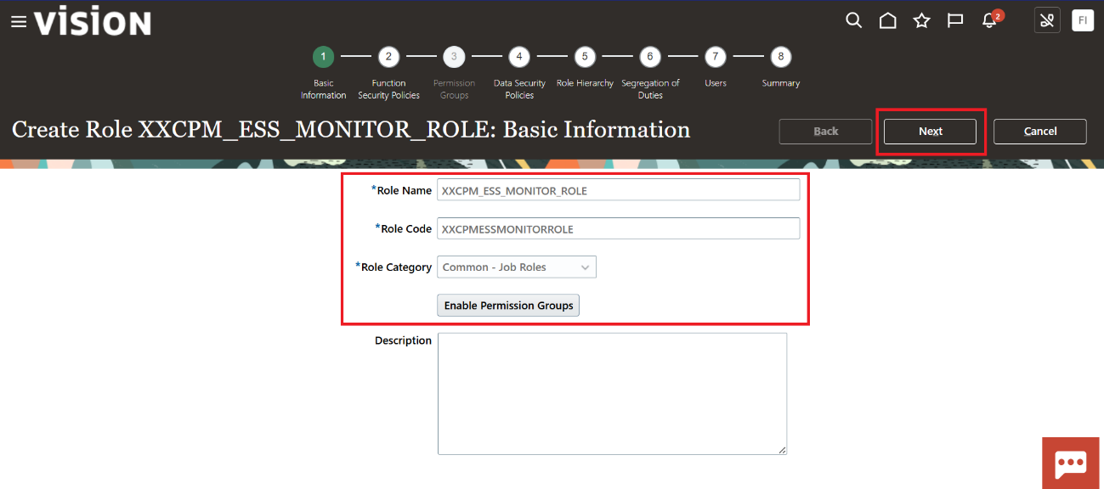

1. Click on Next and Navigate to Role Hierarchy and click on Add Role.

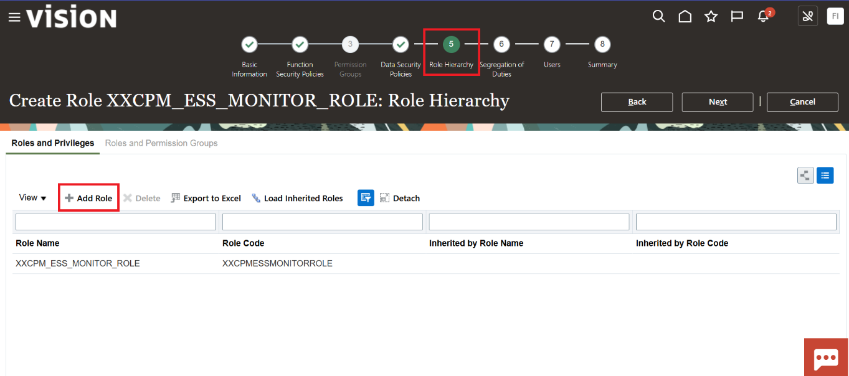

1. Search for ESSMonitor Role and click on Add Role Membership.

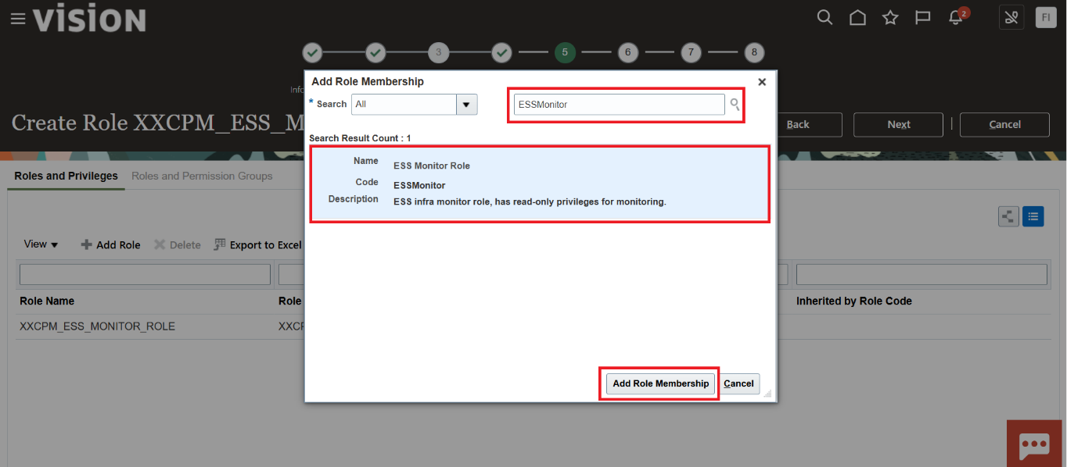

1. Check if the Standard role has been attached to the Custom Role.

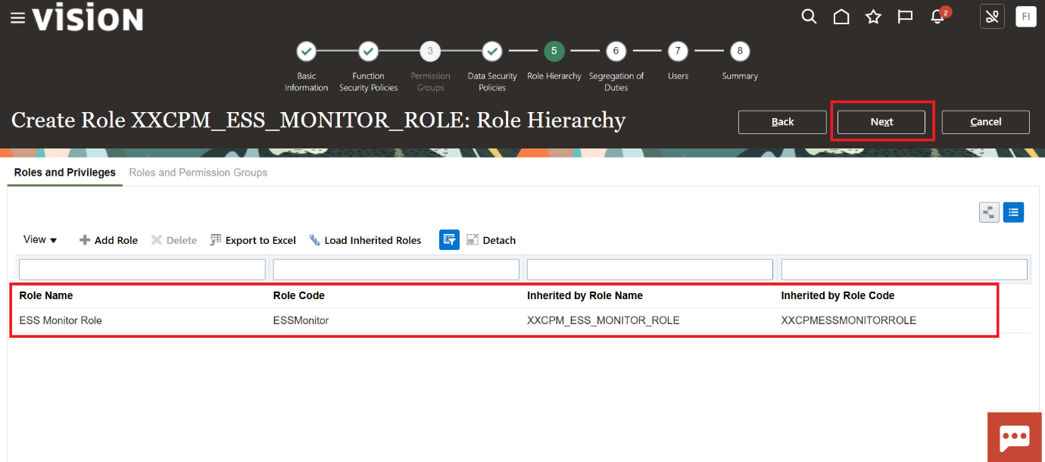

1. Navigate to next screens and go to Summary page and Click on Save and Close.

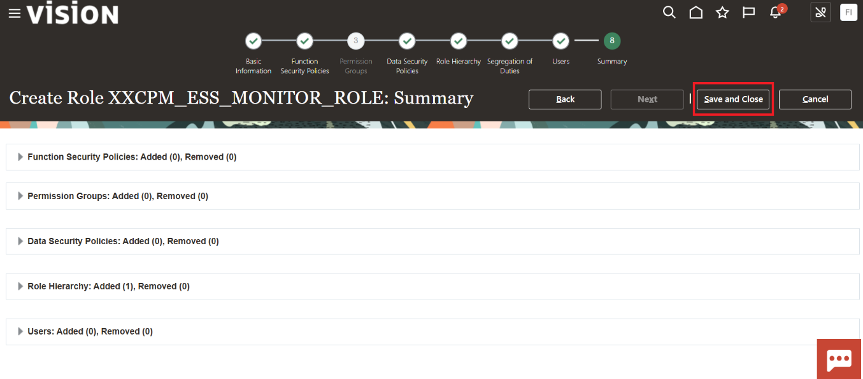

1. Navigate to Users Screen, select the OAuth user, click on edit and Click on Add role.

Select the Custom role which has been defined in above steps.

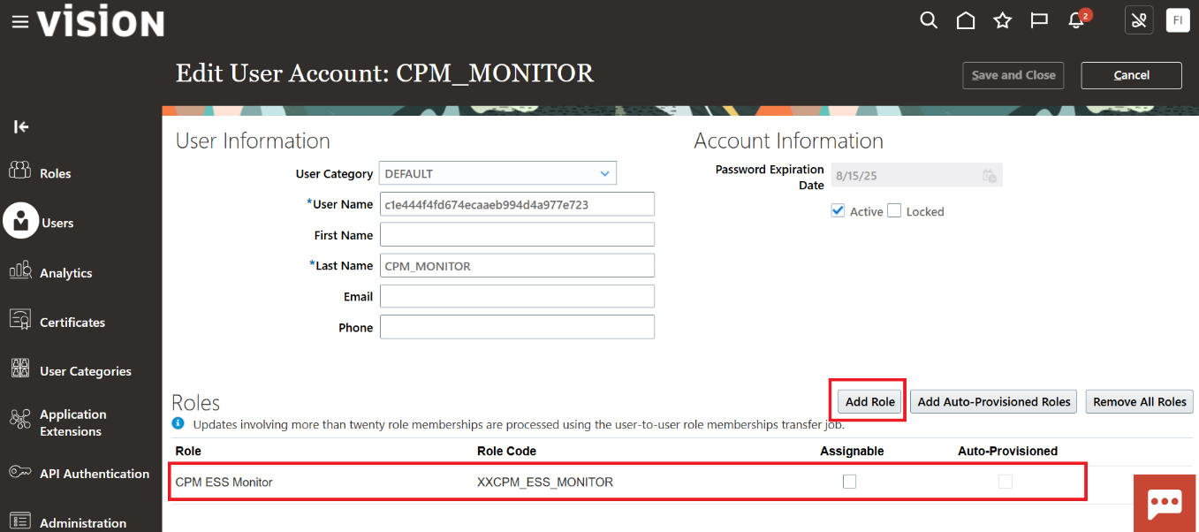

1. Navigate to Scheduled Process and Click on Schedule New Process and select Retrieve Latest LDAP Changes, and submit the process. This process syncs the user accounts.
2. Validate the assigned Role and Save the User Creation

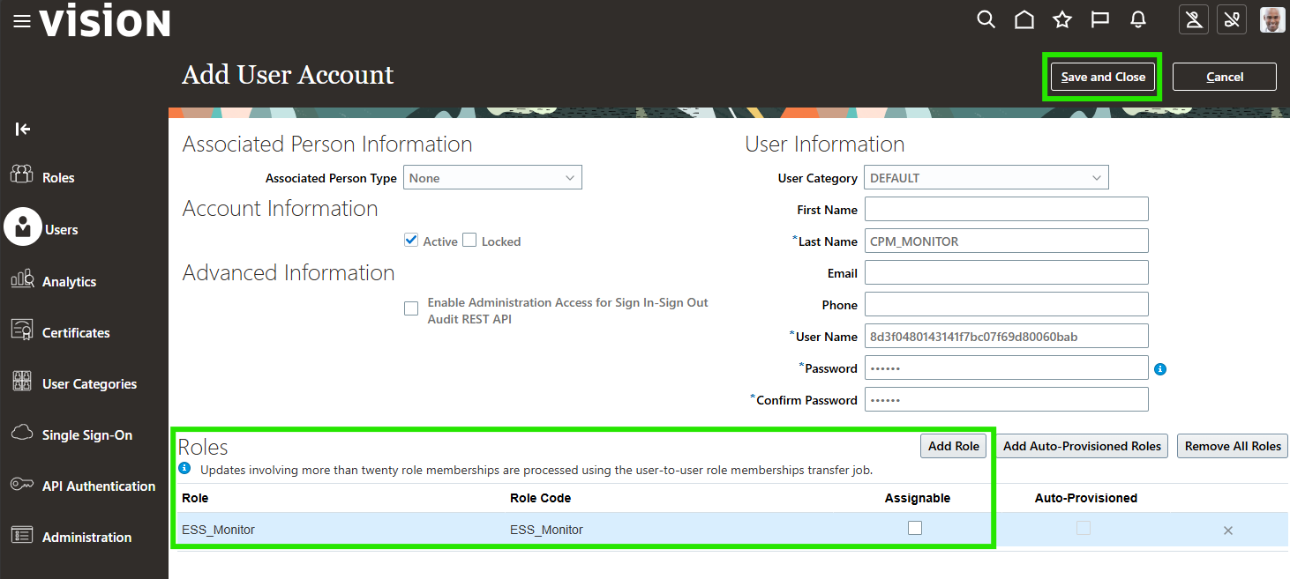

1. Search for the User created and make sure it is Active

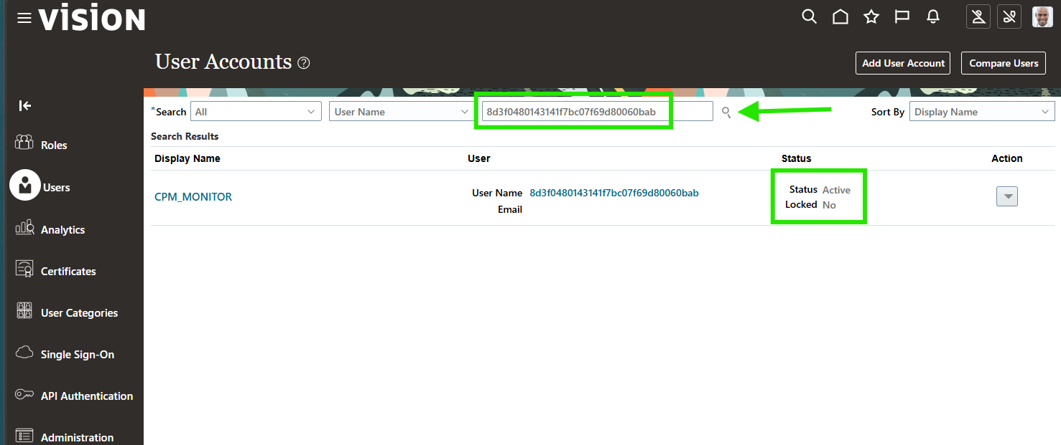

1. Make Sure that you have the following recorded in your Artifacts Notepad File and Save it.

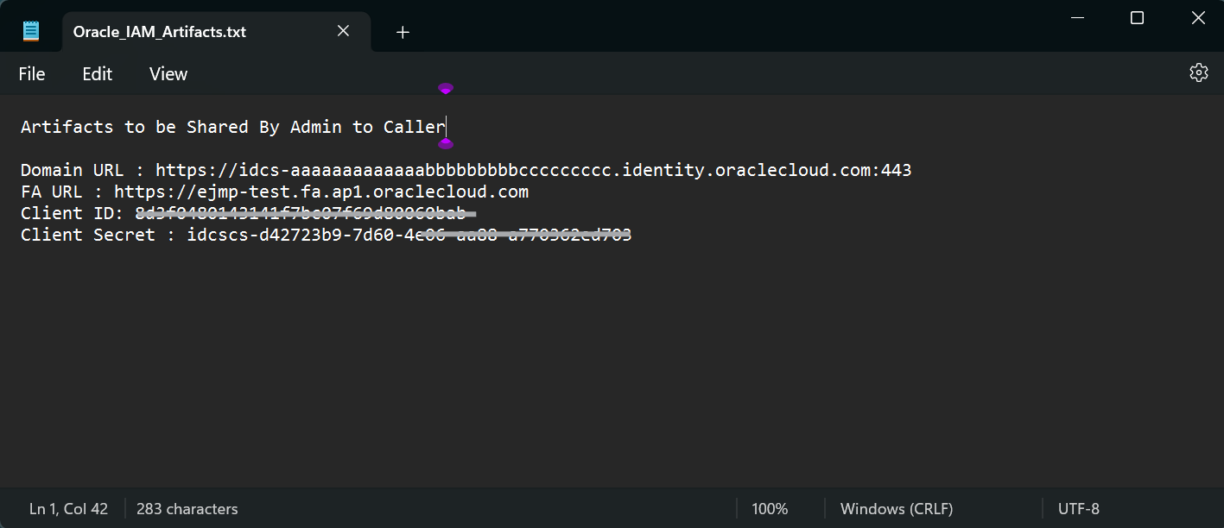

# Important Info To Be Shared By Admin To Caller

Please Share the below information once all are configured to the caller.

